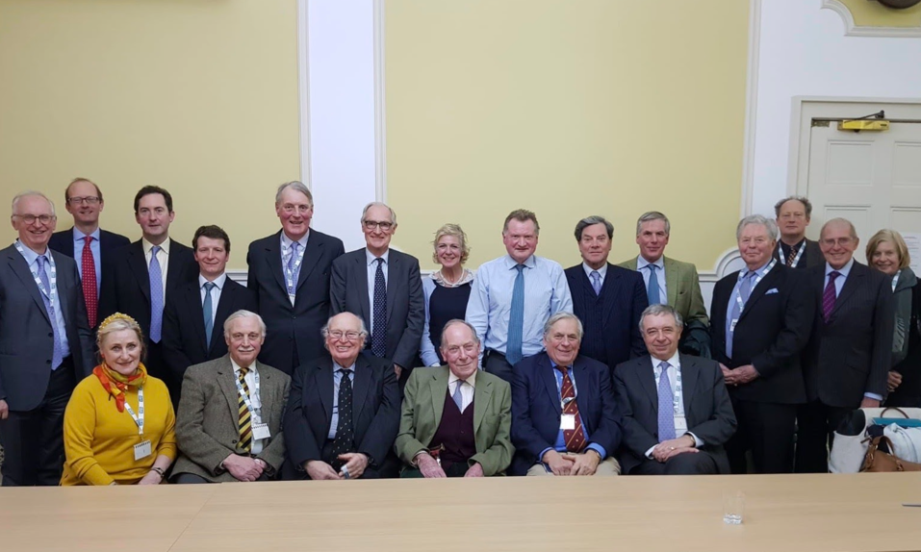
Friends of the Countryside UK

FCS President Michael zu Salm-Salm, CEO Thierry de l'Escaille, Vice Presidents Ross Murray and Seger von Voorst tot Voorst along with many UK FCS members joined in London on February 13, 2020 at the CLA offices to assure the continuation of Friendship across the Channel.
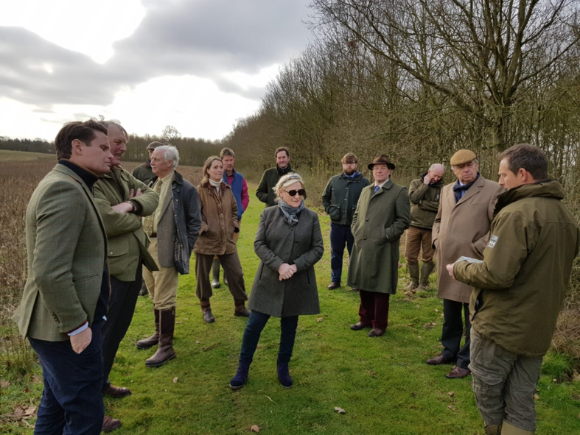
"Our political journey in the UK has strengthened my own feelings about the importance of maintaining the hand of friendship across the water. So much of our lives as countrymen and women is shared in some way with the continent and also Ireland- whether culturally, economically, climatically orpolitically. And it seems careless to end friendships when they will remain such important aspects of our lives in this small world we live in. I hope you will share this view and may wish to continue in membership of the Friends of the Countryside with all its associations to the ELO, and to enjoy what they both have to offer." Ross Murray, FCS Vice President.
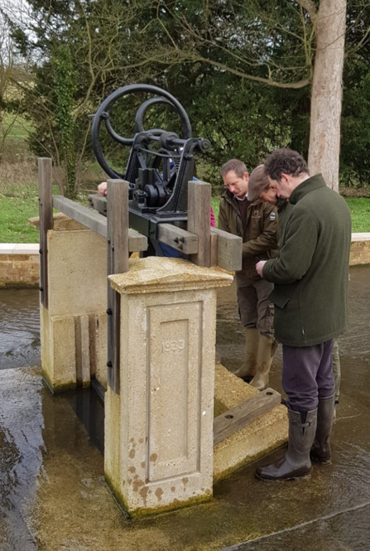
The following day, the FCS contingency were kindly invited by Ralph Abel-Smith to visit Woodhall Estate.
In the same week that both a Wildlife Estate England meeting and a Friends of the Countryside meeting took place in London, my family and I had the pleasure of welcoming a group to the Woodhall Estate in Hertfordshire which is one the first five Accredited Estates in England. The tour took in topical points of interest relating to the environmental and biodiversity initiatives that have contributed to the granting of the Wildlife Estates Accreditation.
In particular the party saw the ancient 16th century oak trees standing in the historic parkland and viewed the recently restored lake, river course and weir with keen anticipation of the additional environment and biodiversity that they will now generate, including a new chalk stream.
Please see www.woodhallestate.co.uk for further information.
Ralph Abel-Smith.

